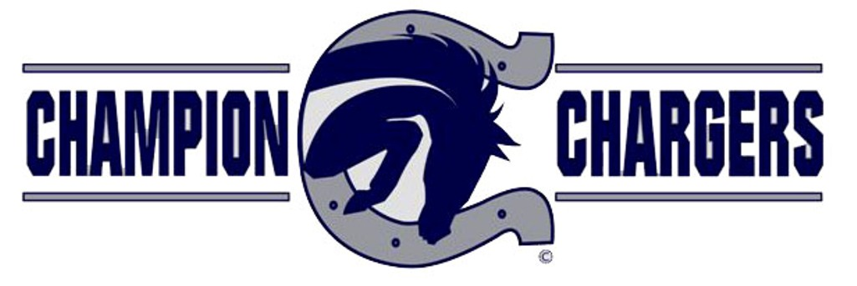

Hello Charger Fan!
Thank you for supporting Charger Football by making a reserved season ticket purchase in 2021. Season ticket renewals for the 2022 football season will begin on Friday, June 24th at 8:00 a.m. and end on July 2nd at midnight.
As you may know, Boerne ISD has a new online ticketing provider, Hometown Ticketing! You will be receiving an email from Hometown Ticketing on June 24th with a link to renew your tickets.
You will only be permitted to renew the tickets you currently hold.
If you wish to change seats, you will still need to renew your tickets and a trade day will be available in August.
All renewal orders must be placed by midnight on July 2^{nd,} or you will forfeit your seats for the 2022 season.
Ticket sales for those who do not currently have season tickets will take place beginning August 3rd at 8:00 a.m. through the ticketing link on the Charger Athletic Page of the Boerne ISD website.
We are looking forward to an exciting 2022 season!
Go Chargers!!

